11.17 TA class summary

第一部分： 作业讲评

一.作业3

Problem 1.6

概念：（书P 70）

互补品：A商品的价格上升，导致B商品需求下降，则A和B为互补品

替代品：A商品的价格上升，导致B商品需求上升，则A和B为替代品

本题中，根据解析式，若P1和I不变，P2增大，q1增大，说明商品2的价格上升，导致商品1需求上升，则商品1和商品2为替代品

Problem 2.3

注意题目中坐标轴中y轴表示的是食品支出，不是人们对食品消费的数量，所以要进行讨论。

概念：（书P70）：

normal good：其他条件相同时，收入增加引起需求增加的物品

inferior good：其他条件相同时，收入增加引起需求减少的物品

ANS：Based on this data alone, we cannot conclude definitely whether food is normal. The definition of a normal good is that quantity demanded QQ increases with income I (other things being equal 1), whereas the data show that expenditure, which is P×Q, increases with I.

It is possible for food expenditure to increase with I while food is actually inferior. Consider this scenario: people with higher income tend to live in more expensive cities. In more expensive cities, the cost of supplying food is higher (higher rent, higher labor cost, etc). Thus even if food is inferior, so that higher income people want to buy less food, they may still end up spending more on food because food is more expensive in the places where they live. Thus we could observe a positive correlation between food expenditure and income even when food is inferior .

注：本次作业中画图的部分，部分同学斜率与正确的不一致，如果趋势对，助教也给了分数，以后要注意取值和画图

Problem 3.5

根据第四问，玉米和原油的价格是相关的，所以他们是替代品

Problem 3.6

讨论时需要保证其他的因素不变，改变一个量，再联系实际情况

ANS：There are other possibilities that may cause the prices of corn and crude oil to move together. One such possibility is change in people’s income. When people’s income rises, they demand both more ethanol/corn and more gas/crude oil , and when their income falls , they demand less of both. This has nothing to do whether corn and crude oil are substitutes or not, but can lead their prices to rise and fall together.

Another possibility is that the price of oil can affect the cost of supplying corn and vice versa, since both are used to produce fuel for transportation. Yet another (theoretical) possibility is if the costs of supplying corn and crude oil are positively correlated themselves. In that case their prices will be positively correlated too, other things being equal.

二、作业4

Part I

1. The demand for natural gas is more inelastic over a short period of time than over a long period of time.因为短期内汽油的需求不会有很大变化，长期内因技术革新、政府政策等，汽油可能会被其他产品取代，需求会发生变化。
2. 概念：（书P91-92）

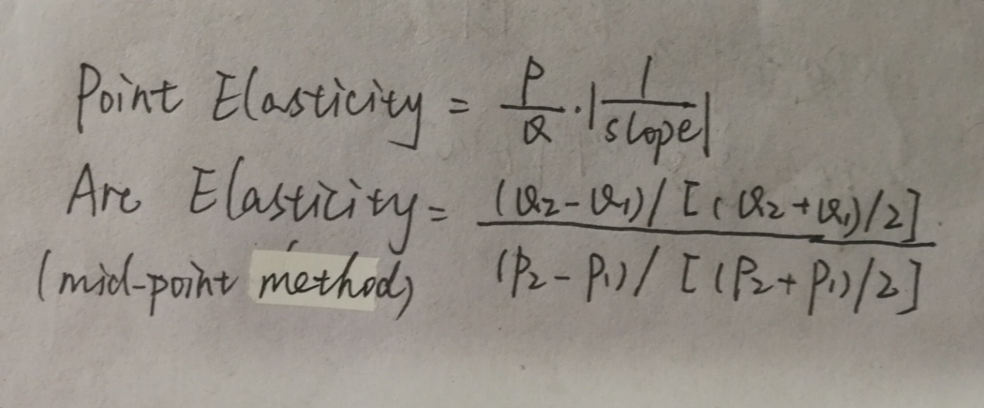

本题用mid-point 方法算 （6/17）/ (10/30)=1.06

1. 用数学方法计算

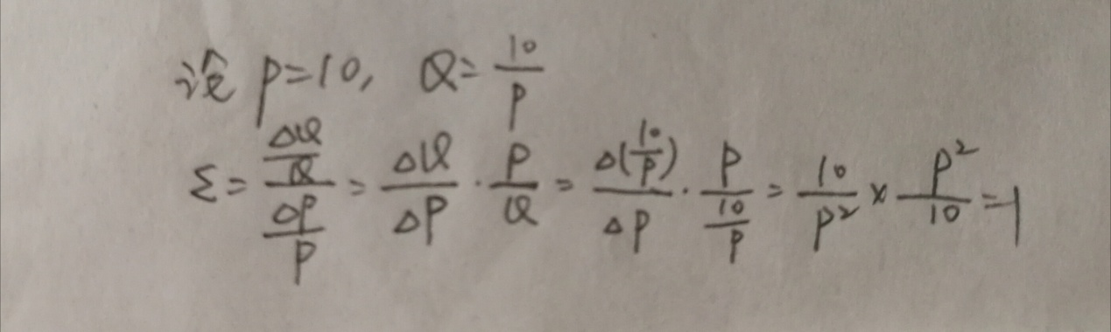

Unit elastic demand：Elasticity = 1

4．概念（书P98）

cross-price elasticity of demand =

△％Quantity demanded of good 1/△％Price of good 2

本题中，商品Y价格升高，同时商品X销售数量增加，所以X和Y是替代品。注意要计算商品单价

cross-price elasticity of demand = (20/30)/(1/2.5)=1.67

1. junk-food ban和 nutrition-education programs会影响消费者

前者使垃圾食品的供应量降低，如果需求不变的话，价格会升高

后者使垃圾食品的供应量降低，需求降低，价格会降低

Problem 2.1

保证有因素不变，改变一个量，本题中保证income和concert price不变，改变dinner price

Problem 3

保证demand曲线没有移动，price和quantity变化是因为supply曲线移动

Problem 4 注意需要摘抄出错误的话

三、作业5

1.商品市场上，价格会有波动，但是价格是围绕价值波动的

2.关于求平方根的函数 sqrt（）

3.Problem 5.4 可以重新赋值

a = log(p) b=log(q)

abline(lm(a~b))

4.Problem5.5

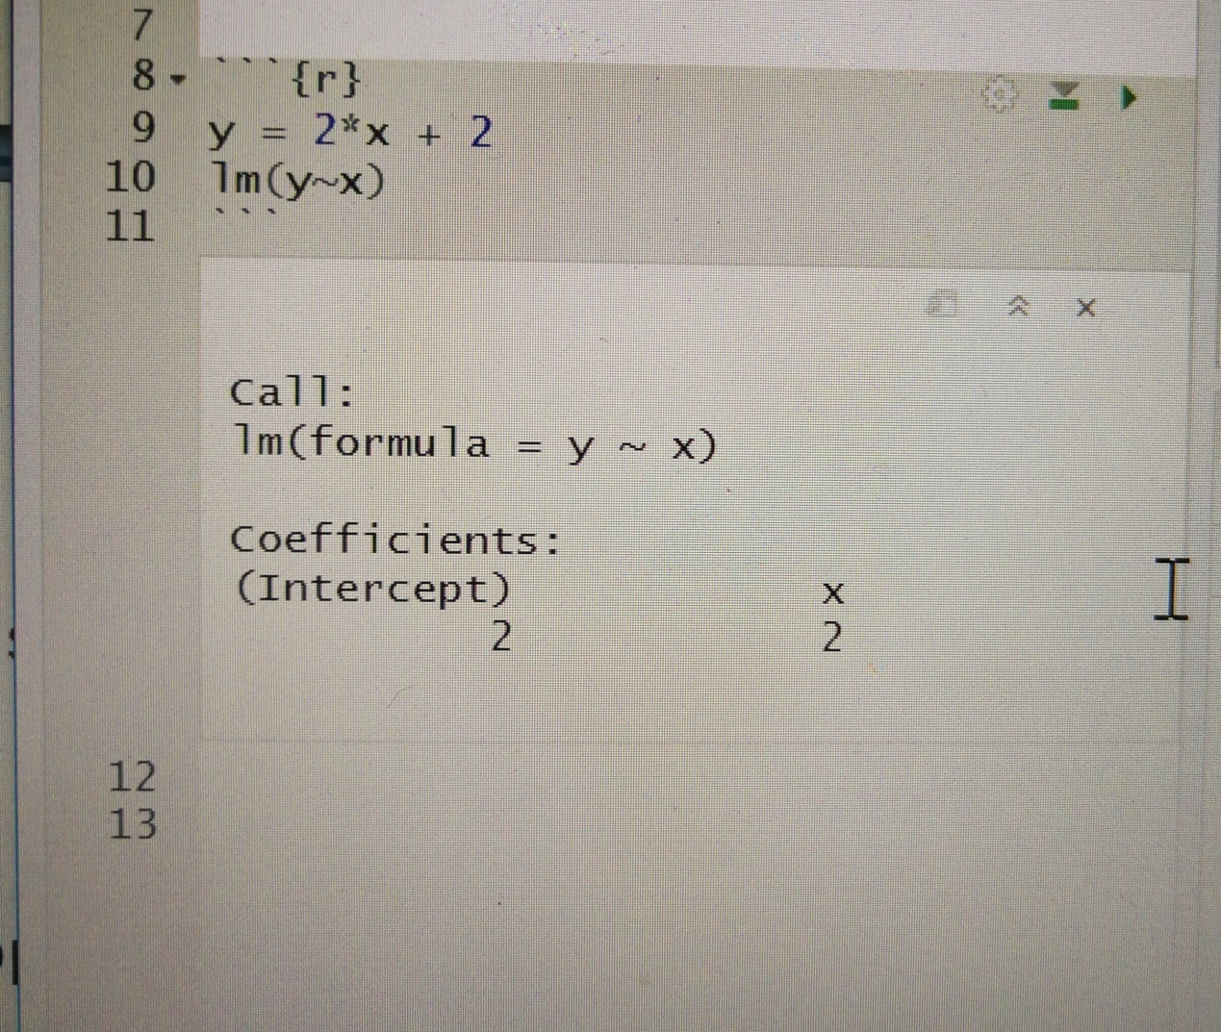

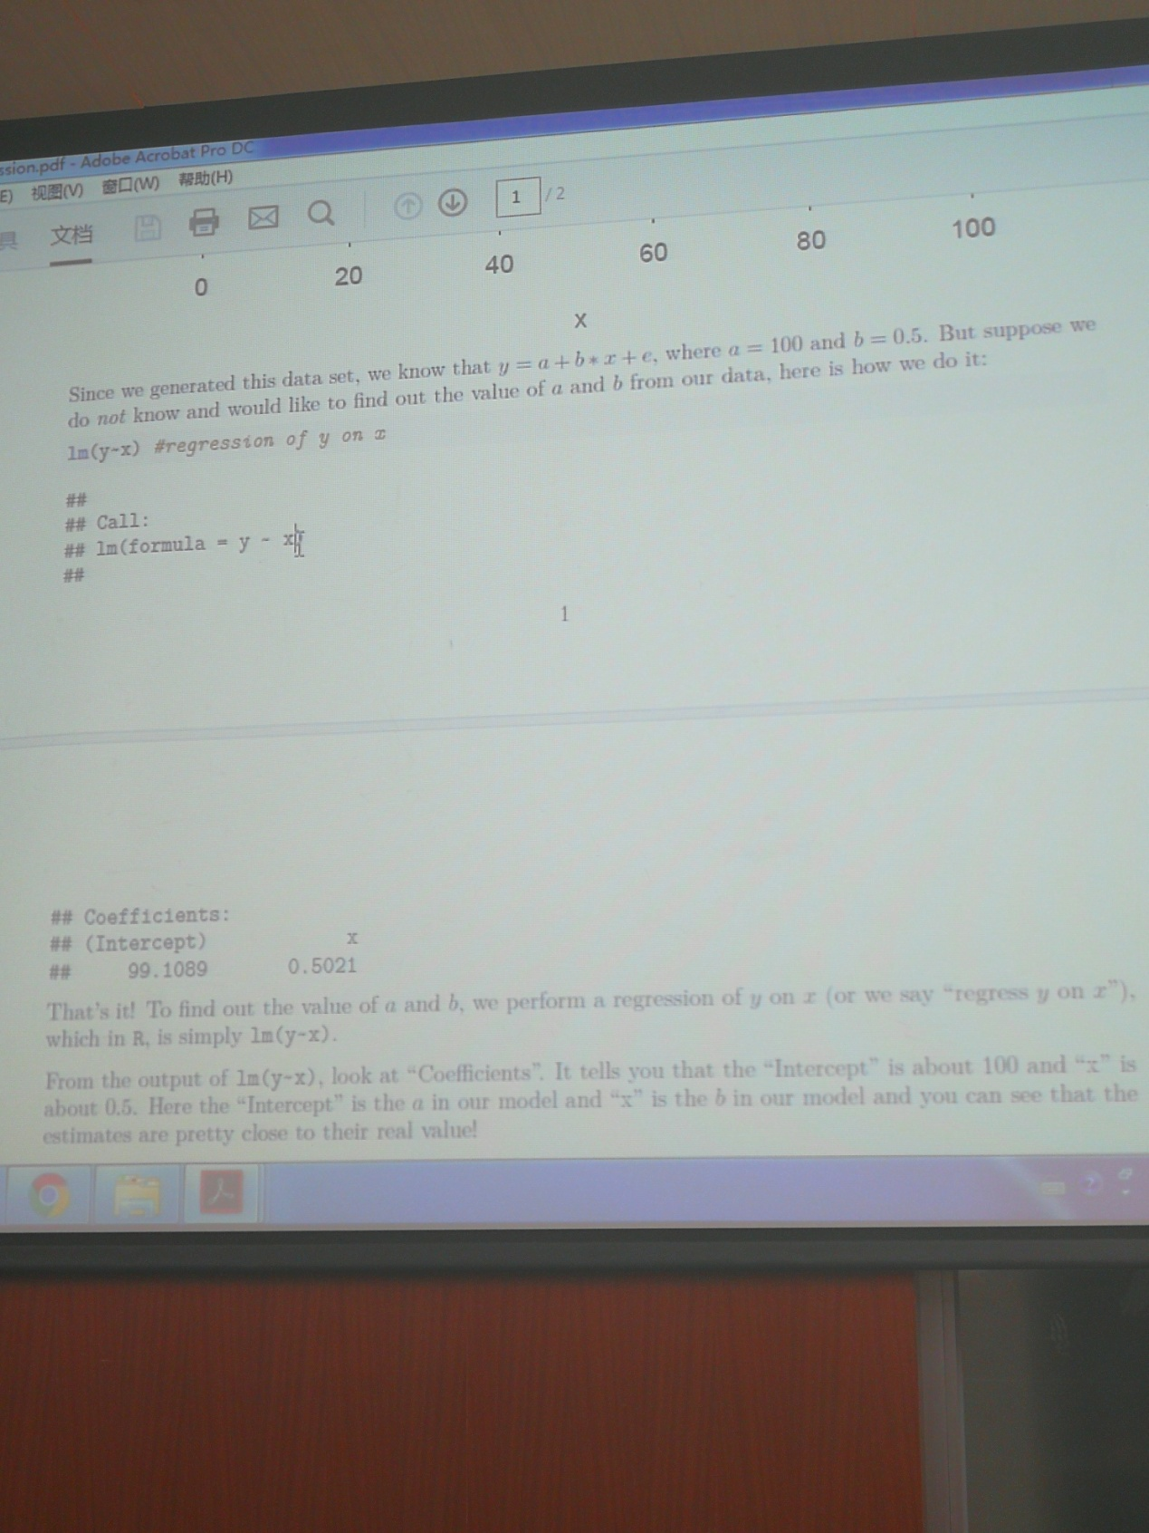

5.Problem6 解释基于点来画直线和基于曲线来画直线有不同

第二部分：Welfare （详情看课件）

1. 需求和供求曲线是怎么来的，

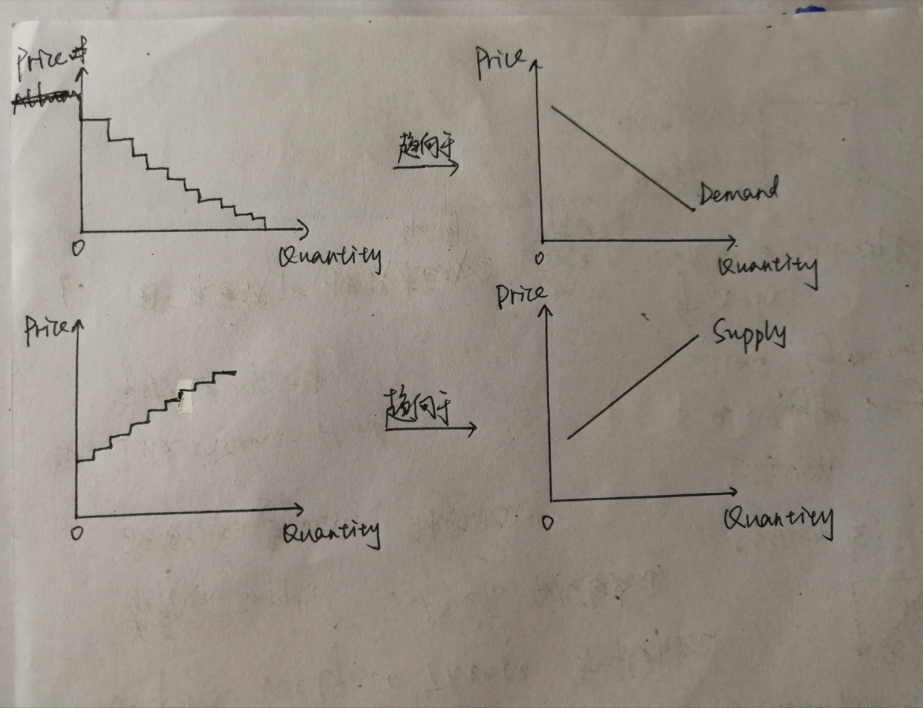

1. Willingness to pay (书P136)指买者愿意买这个东西所付出的最大值
2. （书P145）Consumer surplus = Value to buyers – amount paid by buyers

Producer surplus = amount received by sellers – cost to sellers

1. Market efficiency & First welfare Theorem (第一福利理论)（书P144）

前者是指，当一样事物受买者喜欢，买的人很多，卖者发现有商机，供给增加，一段时间之后，需求量小于供给量，卖者有部分退出，供给下降，形成循环。后者指市场中每人的每个人都做对自己有利的事，把自己要做的事完成，整个市场就会运行下去。

1. Invisible hand: 市场是看不见的手

Tax（详情看课件）

1. tax can be a percentage of transaction(ad valorem tax)or a specific amount per unit of goods sold(per unit tax),主要用 per unit tax算
2. elasticity (eg.if supply is more elastic than demand,consumers tax more.)
3. deadmeight loss
4. subsidy

——王卢兰